Nischal Shrestha
Coventry University Student ID Number: 17103446
B.Sc. (Hons.) Computing, Softwarica College of IT and E-commerce, Coventry University ST4005CEM Database System
Giriraj Rawat

- Find the total billing amount paid by each patient. Display PatientID and total amount.
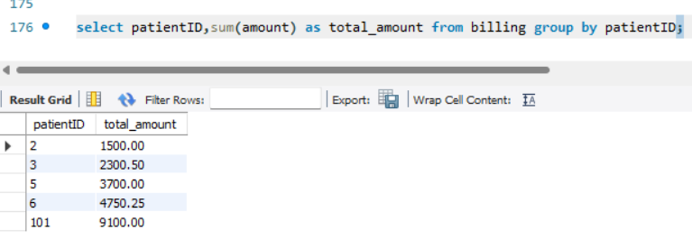
- Count the total number of appointments booked for each doctor. Display Doctorname and appointment count.
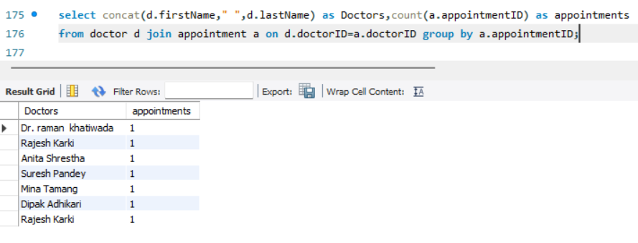
- Find the average billing amount from the Billing table.
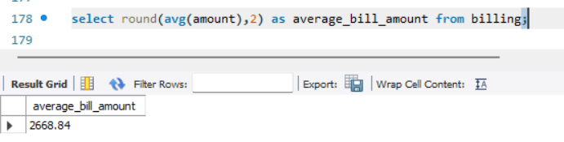

- Display the maximum and minimum billing amount recorded in the Billing table.
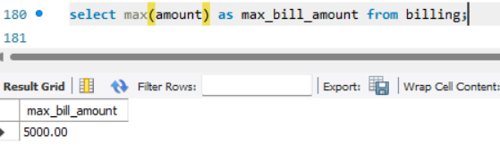
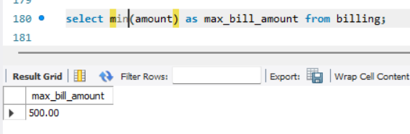

- List all doctors who have issued more than 2 prescriptions. Display doctorname and prescription count.
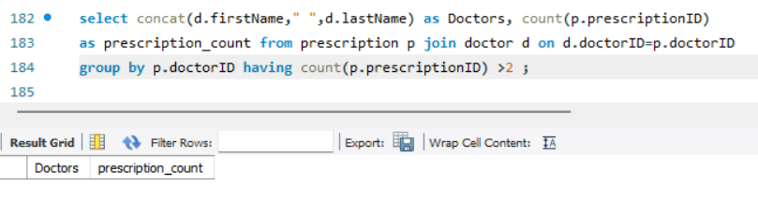

- Find the total number of medical records grouped by Diagnosis. Display Diagnosis and record count.
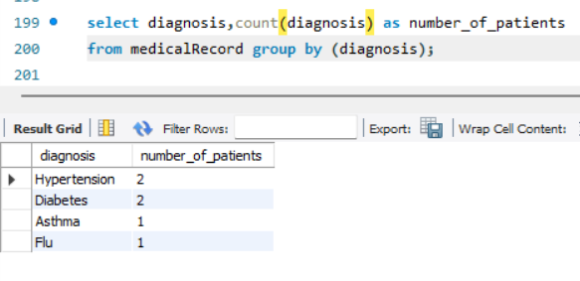
- Display the full name of each patient along with their diagnosis from the MedicalRecord table.
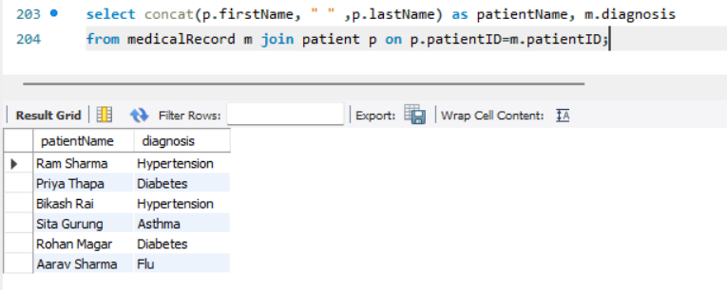

- List all appointments along with the patient's first name, last name, and the doctor's first name and last name.
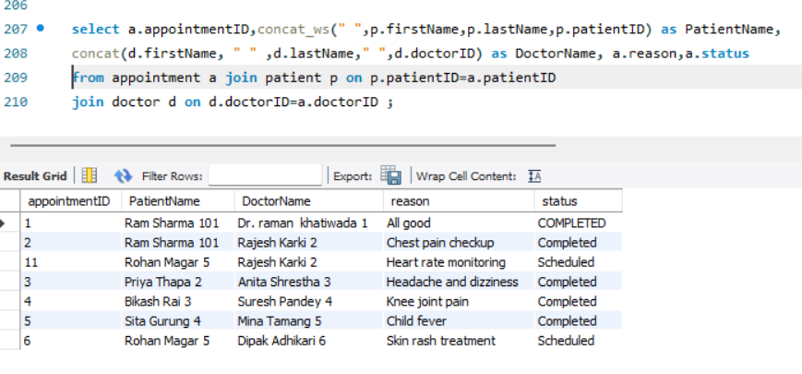

- Show all prescriptions along with the medication name, patient name, and the prescribing doctor's name.
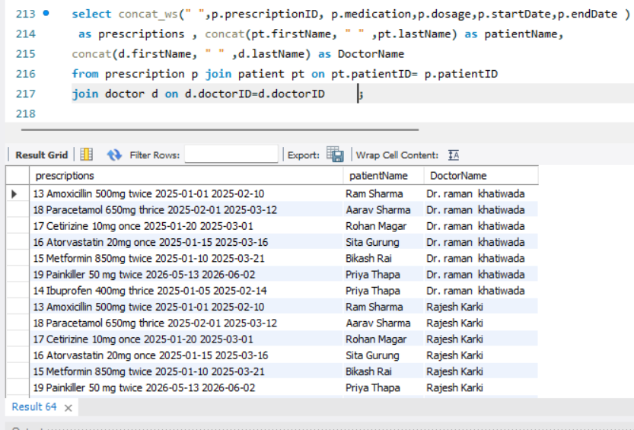

- List all patients and their billing details. Include patients who have no billing records as well.
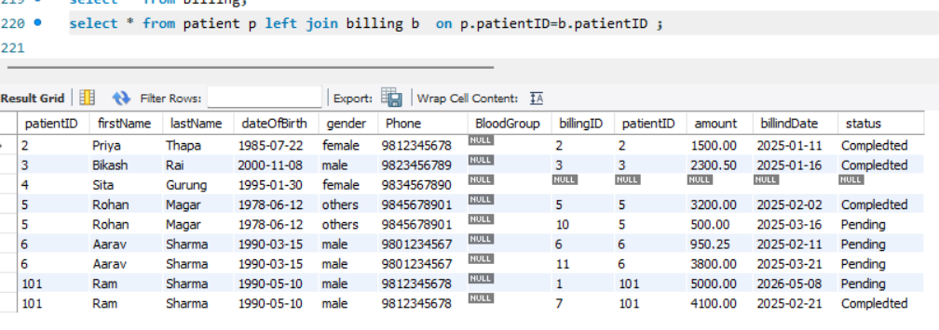

- Display all doctors and any appointments they have. Show doctors with no appointments too.
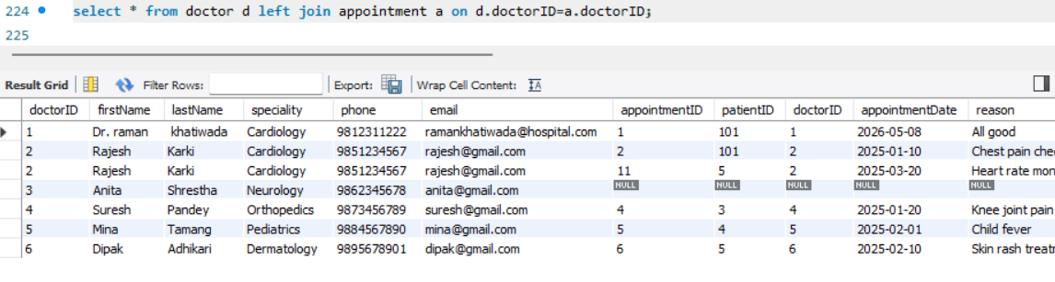
- Find each patient's full name and the total amount billed to them by joining Patient and Billing tables.
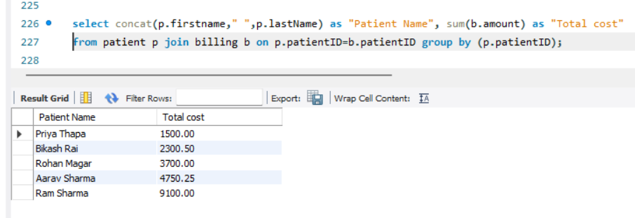

- List appointment details (date, reason, status) together with the patient's gender and contact info.
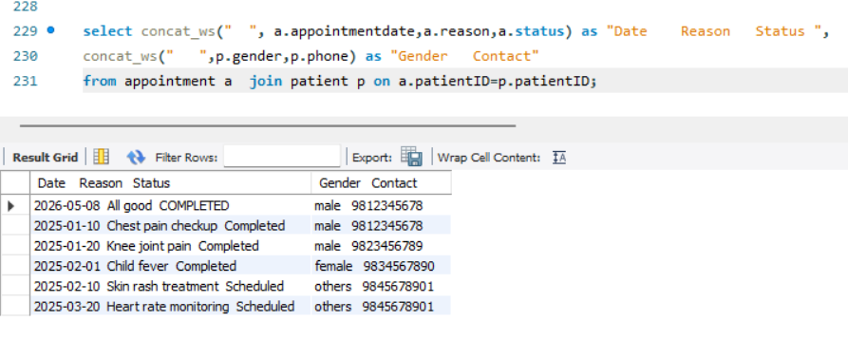

- Retrieve all appointments where the status is 'Scheduled' and appointments is after Jan 1 2026.
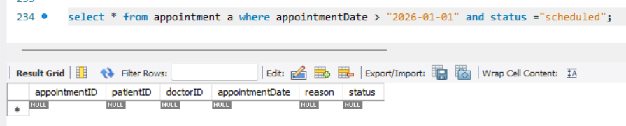

- Find all patients whose first name starts with the letter 'A'.
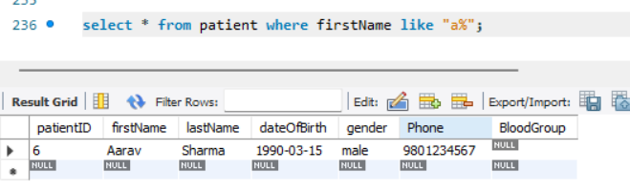

- Display all billing records where the amount is between 500 and 2000.
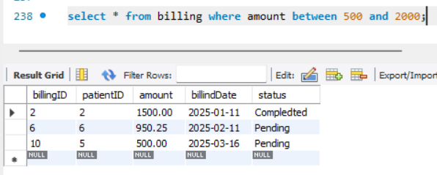

- List all prescriptions where the medication is either 'Paracetamol', 'Ibuprofen', or 'Amoxicillin'.
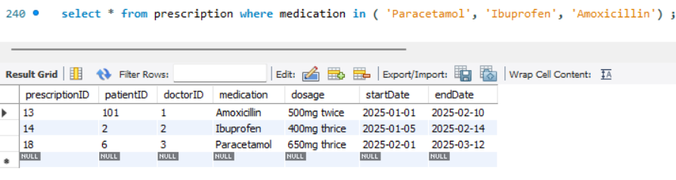

- Retrieve medical records where the treatment contains the word 'Surgery' or the notes are not null.
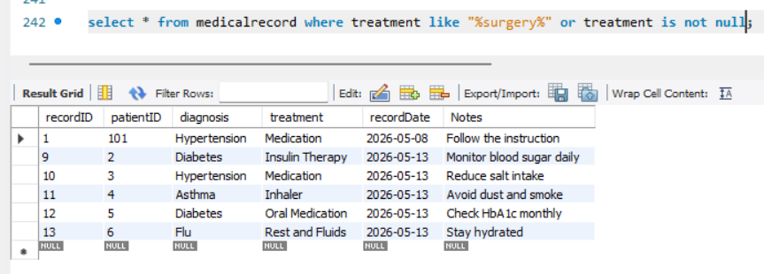

- Add a new column called BloodGroup of type VARCHAR(5) to the Patient table.
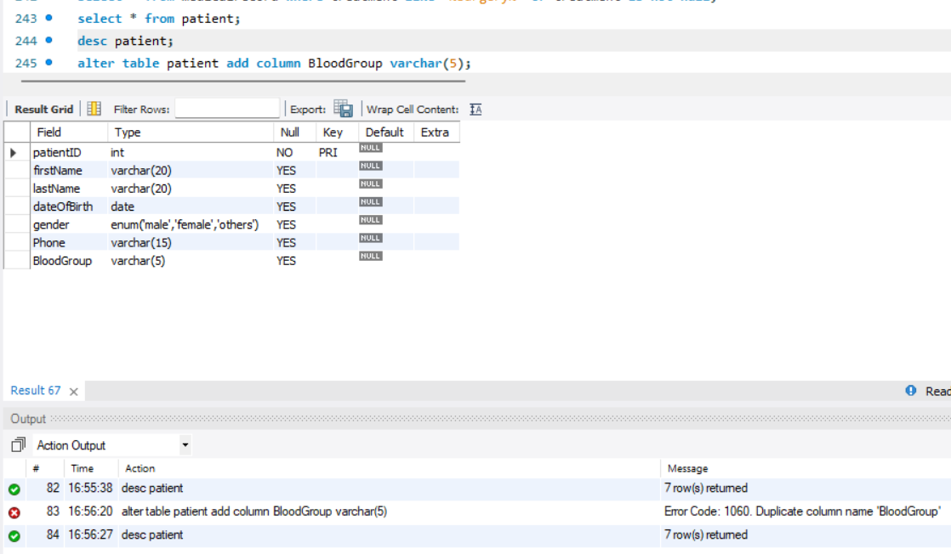
- Modify the Phone column in the Doctor table to change its data type from VARCHAR(15) to VARCHAR(20).
